Όνομα : ___________________ Ημερομηνία : _________________

1. Συμπληρώνω την παρεούλα του 10:
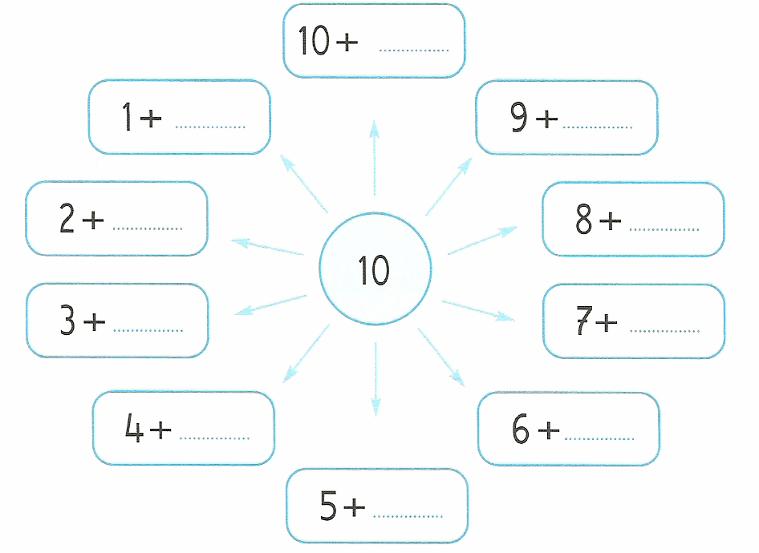


2. Συμπληρώνω τα διπλά αθροίσματα και μαθαίνω πολύ καλά:
1 | + | 1 | =
2 | + | 2 | =
3 | + | 3 | =
4 | + | 4 | =
5 | + | 5 | =
6 | + | 6 | =
7 | + | 7 | =
8 | + | 8 | =
9 | + | 9 | =
10 | + | 10 | =



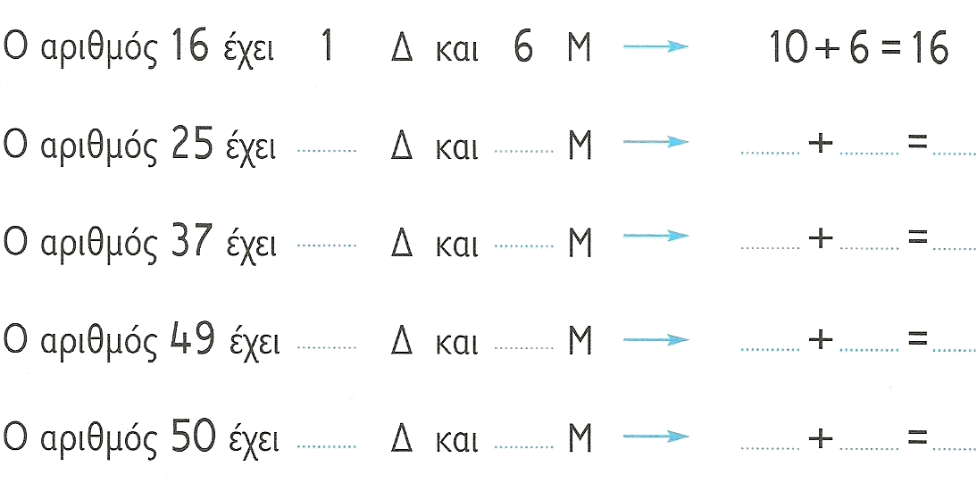
3. Συμπληρώνω σωστά:

4. Κάνω τις παρακάτω πράξεις:

6 | + | 3 | = |  |  | 20 | + | 5 | = |  |  | 15 | - | __ | = | 10
8 | - | 4 | = |  |  | 25 | - | 5 | = |  |  | 10 | + | __ | = | 18
9 | - | 5 | = |  |  | 25 | - | 20 | = |  |  | 28 | - | __ | = | 20
7 | - | 3 | = |  |  | 30 | + | 8 | = |  |  | 10 | - | __ | = | 8
3 | + | 5 | = |  |  | 38 | - | 8 | = |  |  | 5 | + | __ | = | 9
5 | + | 2 | = |  |  | 38 | - | 30 | = |  |  | 3 | + | __ | = | 7

5. Υπολογίζω πόσα χρήματα έχω κάθε φορά:
   | __ + __ + __ + __ = __€
 | __ + __ + __ + __ + __ = __€
 | __ + __ + __ + __ + __ + __ = __€
 |   __ + __ + __ = __€
 | __ + __ + __ + __ = __€

